Azure Data Integration using DataFactory

Cost Analysis:

**Pipeline Execution**

This is the cost for the compute resources required for Pipeline execution. You can expect the bulk of the cost for Azure Data Factory pipelines to fall into this category. This is further divided into three sub-categories :

* **Data movement activities** : This covers the cost of moving data across data stores in activities such as the copy data activity.
* **Pipeline activities** : Pipeline activities such as Lookup, Delete and schema operations during authoring (test connection, browse folder list and table list, get schema, and preview data).
* **External activities** : These are data transformation activities that execute in a computing environment such as Azure Databricks or Azure HDInsight. You can find a list of external activities [here](https://docs.microsoft.com/en-us/azure/data-factory/transform-data).

Each sub-category has separate pricing, as listed below:

**Self hosted**

* Data movement : **$0.10/hour**
* Pipeline activities : **$0.002/hour**
* External activities : **$0.0001/hour**

**Azure Integration runtime**

* Data movement : **$0.25/DIU-hour**
* Pipeline activities : **$0.005/hour**
* External activities : **$0.00025/hour**

You may have noticed that every sub-category is charged by the hour except Data movement which is charged in units of DIU-hour.

“A Data Integration Unit (DIU) is a measure that represents the power of a single unit in Azure Data Factory. Power is a combination of CPU, memory, and network resource allocation.” A DIU therefore, is a measure of the compute resources available to your pipeline. The more compute you allocate, the higher the cost.

The copy activity is configured to use 4 DIUs by default but you can modify this to set the value between 2 and 256 depending on your performance requirements. You can find a detailed article on DIUs and how to optimize costs and performance for the copy activity [here](https://docs.microsoft.com/en-us/azure/data-factory/copy-activity-performance).

Azure Also charges for **inactive pipelines** so its good to clean up after you’re done. A pipeline is considered inactive if it has no associated trigger or any runs within the month. An inactive pipeline is charged at **$0.80 per month**.

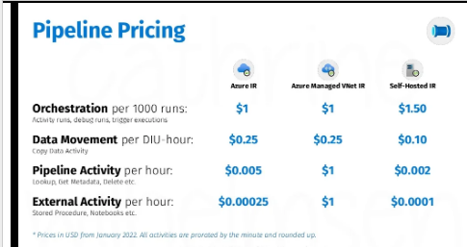

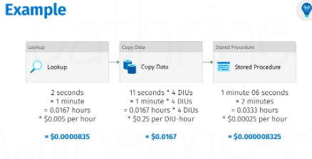

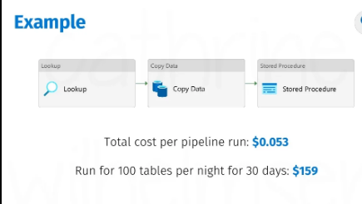

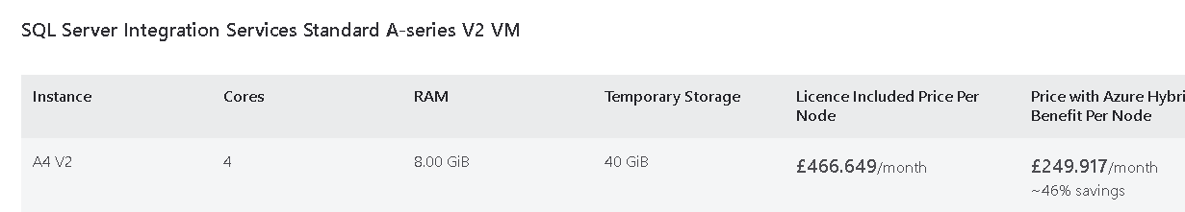

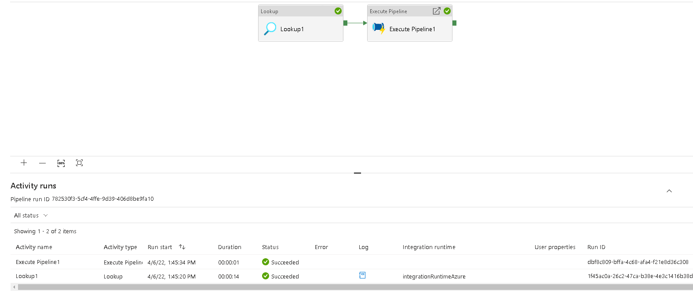

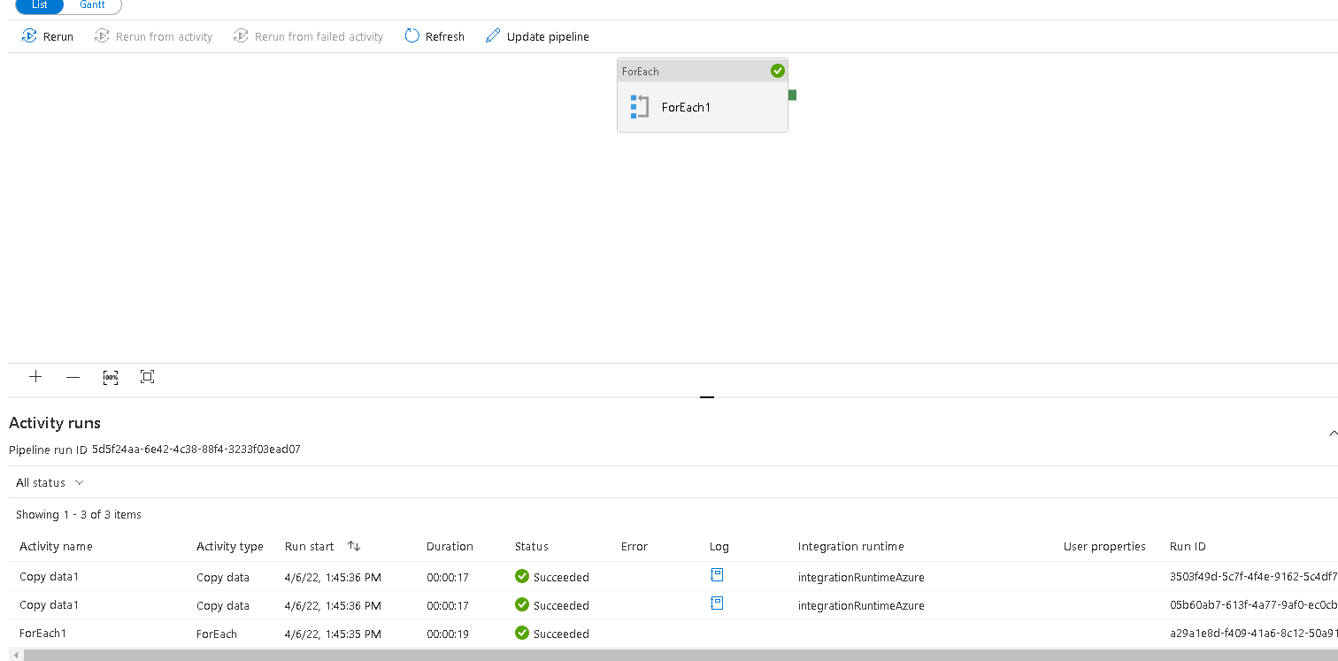



For each,Lookup/min:

0.000835:12£

Copy data/min:

0.0167